# BANGALORE’S TRAFFIC PULSE

## DATA DESCRIPTION

1. Area Name - Categorical Data, Nominal
2. Road/Intersection Name - Categorical Data, Nominal
3. Traffic Volume - Discrete Data
4. Average Speed - Continuous Data
5. Travel Time Index - Continuous Data
6. Congestion Level - Continuous Data
7. Road Capacity Utilization - Continuous Data
8. Incidents Reports - Discrete Data
9. Environmental Impact - Continuous Data
10. Public Transport Usage - Continuous Data
11. Traffic Signal Compliance - Continuous Data
12. Parking Usage - Continuous Data
13. Pedestrian and Cyclist Count - Discrete Data
14. Weather Conditions - Categorical Data
15. Roadwork and Construction Activity - Categorical Data
16. Time of Day - Categorical Data (Morning, Afternoon, Evening, Night)

**Unraveling Bengaluru’s Traffic Dynamics**

**Introduction:** Bangalore, often hailed as India's Silicon Valley, faces a monumental challenge: traffic congestion. With a growing population, burgeoning tech industry, and rapid urbanization, understanding the city's traffic trends is crucial to improve infrastructure, reduce environmental impact, and enhance commuters' lives. This analysis delves deep into various aspects of Bangalore's traffic, using a rich dataset that tracks key factors like traffic volume, average speed, congestion, and incidents.

By analyzing this data, the project aims to identify traffic trends, problematic intersections, and the relationship between traffic volume, congestion, and environmental impact. This analysis can help city planners, policymakers, and residents better understand the dynamics of Bangalore's traffic, aiding in the development of more efficient traffic management strategies. The findings of this analysis will provide valuable insights for improving road infrastructure, reducing traffic jams, enhancing public transport systems, and promoting sustainable urban mobility solutions in Bangalore.

**DATA ANALYSIS AND VISUALIZATION**

1. 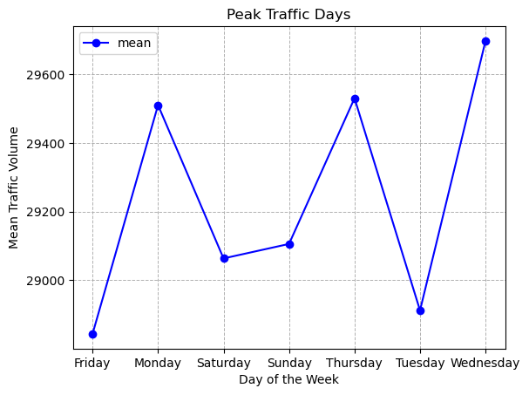**Peak Traffic Days:**

**OBJECTIVE:** Identify which days of the week/month/year have the highest traffic volume

**INSIGHTS**: Analysis of our dataset shows a clear spike in traffic volume during weekdays compared to weekends. Using a line graph for visualization, the trend reveals that traffic steadily increases on working days, likely due to the daily commute to work, schools, and businesses. In contrast, traffic levels drop significantly over weekends, as fewer people commute for work-related purposes.

1. 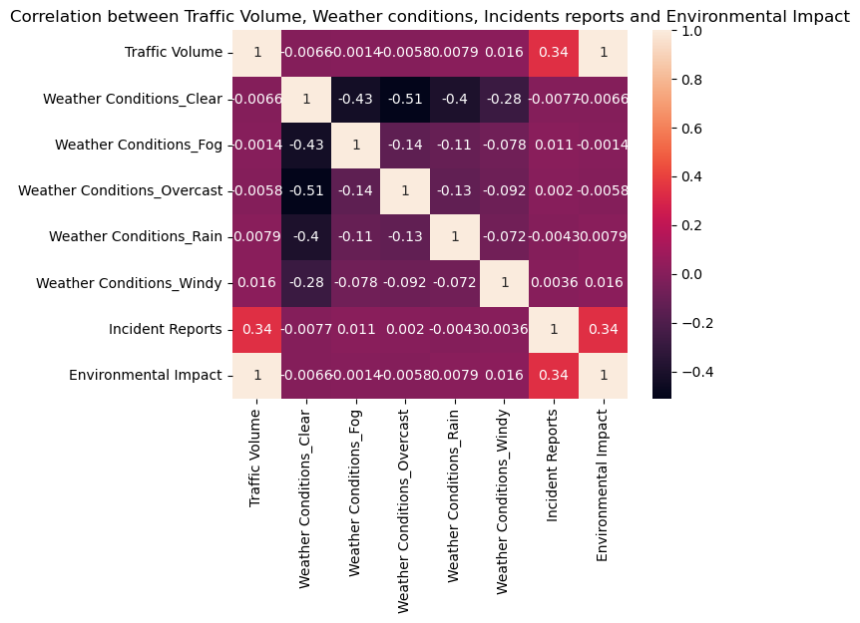**Correlation between Traffic, Incidents, and Climate:**

**OBJECTIVE:** Analyse the relationship between traffic volume, incident reports, and weather conditions.

**INSIGHTS:**

**Traffic and Incidents:**

Typically, higher traffic volumes can lead to more incidents due to congestion and driver frustration. However, in our analysis, we find negative correlation, it could imply that during peak traffic times, drivers may become more cautious, leading to fewer incidents.

* Insight: This might suggest that as traffic increases, drivers adapt their behaviour, resulting in a decrease in the number ofaccidents. Alternatively, certain traffic management measures during high traffic times could effectively reduce incidents.

**Traffic and Climate:**

Adverse weather conditions (like heavy rain or fog) can reduce traffic volume as people are less likely to travel. Conversely, good weather might encourage more trips, leading to increased traffic.

Insight: A negative correlation here might indicate that on days with poor climate conditions, traffic volume decreases, which might also lead to a reduction in incidents due to fewer vehicles on the road.

**Incidents and Climate:**

Bad weather can lead to an increase in incidents (e.g., slippery roads, reduced visibility). However, we find a negative correlation, it could mean that on days with extreme weather, fewer vehicles are on the road, leading to fewer potential accidents.

Insight: This suggests that while weather impacts driving conditions, it also influences driver behaviour and traffic patterns significantly. If fewer drivers are on road during adverse weather, there may be less chance for accidents.

1. **Correlation between Traffic and Construction Activity:**

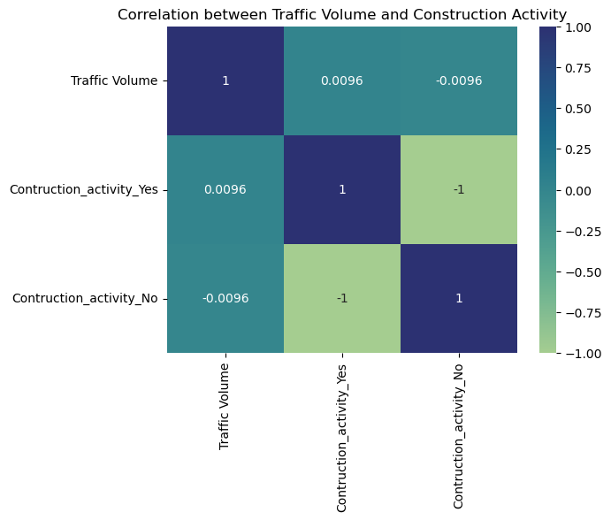

**OBJECTIVE:** Analyse the impact of roadwork and construction activity on traffic.

**INSIGHTS:** In our analysis, we utilized a heatmap to explore correlations between various factors affecting traffic volume. Construction activity seems to have a minimal impact on traffic volume. The weak correlation suggests that other factors may be more significant in influencing traffic levels, such as time of day, road capacity, or traffic incidents.

1. 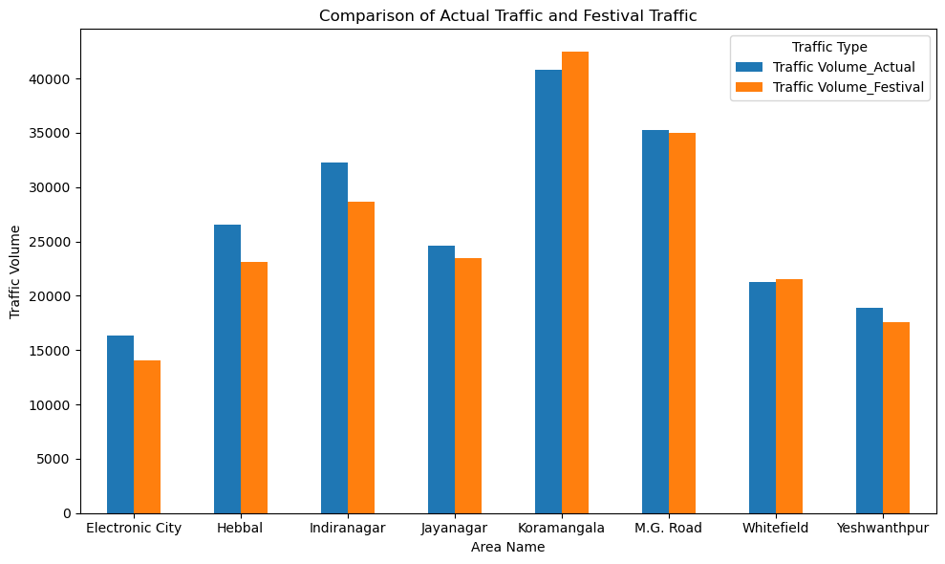**Festivals and Traffic:**

**OBJECTIVE:** Compare traffic patterns during festival days.

**INSIGHTS:** Koramangala stands out as an area of concern during festivals, with an already high traffic volume that increases further. This could indicate the need for additional traffic control measures during festivals in this area. Areas like Hebbal, Whitefield, and Yeshwanthpur experience a drop in traffic during festivals, which might suggest residents avoid these areas during events or that they are not major hubs for festival activities. Here we usedBar graph for visualization

1. 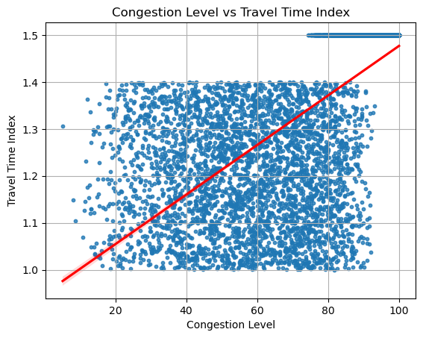**Congestion on Roads and Travel Time:**

**OBJECTIVE:** Understand the relationship between road congestion and travel time**.**

**INSIGHTS**: The scatter plot shows a positive correlation between road congestion and travel time. This means that as congestion levels increase, the travel time also increases. Smart traffic lights and real-time traffic management systems can optimize traffic flow, reducing congestion at intersections.

**LEARNINGS**

Throughout our analysis of Bangalore traffic data, our group gained valuable insights not only into the traffic patterns but also into the art of data visualization itself. One of the most significant lessons we learned is that data visualization is not just about presenting numbers—it’s about uncovering the story behind the data.

Due The lack of time data we had to drop peak traffic time as a factor. This highlights the importance of assessing data availability early in the process and being adaptable with analysis objectives.

We initially believed construction activity was a major cause of traffic but found it was not. This is a great example of how data can disprove assumptions. Visualizations could show a comparison between traffic patterns in areas with and without construction to demonstrate this insight.

This experience highlighted the importance of keeping an open mind during the visualization process and letting the data guide the narrative. Through this journey, we not only became more skilled at creating visualizations but also more adept at questioning our assumptions and refining our methods based on what the data revealed.

In the end, our understanding of how data visualization works evolved significantly—we learned that it’s an iterative process where the insights can sometimes surprise you. Ultimately, it was this dynamic interplay between our assumptions and the actual findings that enriched our overall learning experience.

**Conclusion:**

## The detailed analysis of Bangalore's traffic dataset sheds light on several key areas: peak congestion days and areas, the influence of construction and weather on traffic, and how festivals alter the city's traffic landscape. By examining traffic over the years and the increasing use of public transport, we gain a clearer understanding of how Bangalore's traffic patterns are evolving. These insights are crucial for city planners, policymakers, and citizens as they navigate the complex web of Bangalore's bustling streets.